## Weekly report #1 (Fri 23 Oct 2020)

This was the week in which the Project Initiation document was to be submitted on Thursday 22nd October 2020. My time primarily focused on this and therefore I have declared what software application I am developing for my final year project. As the Project Initiation has been finalised, I now have a detailed projection vision, a risk plan, project backlog, and a GitHub source code repository. Next steps are to populate the backlog with useful information, such as use cases, functional requirements, and general ideas/comments I might have that was not stated in the project vision.

## Weekly report #2 (Fri 30 Oct 2020)

I have created a “Documents” folder in the GitHub repository which now contains a word document for all functional requirements and use cases for both users: Administrator and Parent/Participant. This information has also been replicated in the project backlog alongside with planning my current tasks for this sprint. I also requested web hosting from Shirley Atkinson for when I start developing the system. I have been provided with the details to my web host directory as well as guidance on how to access it and upload files. Next steps are to design the system database and the user interface for the application(s) so I can have an understanding of how it will function and how it would look.

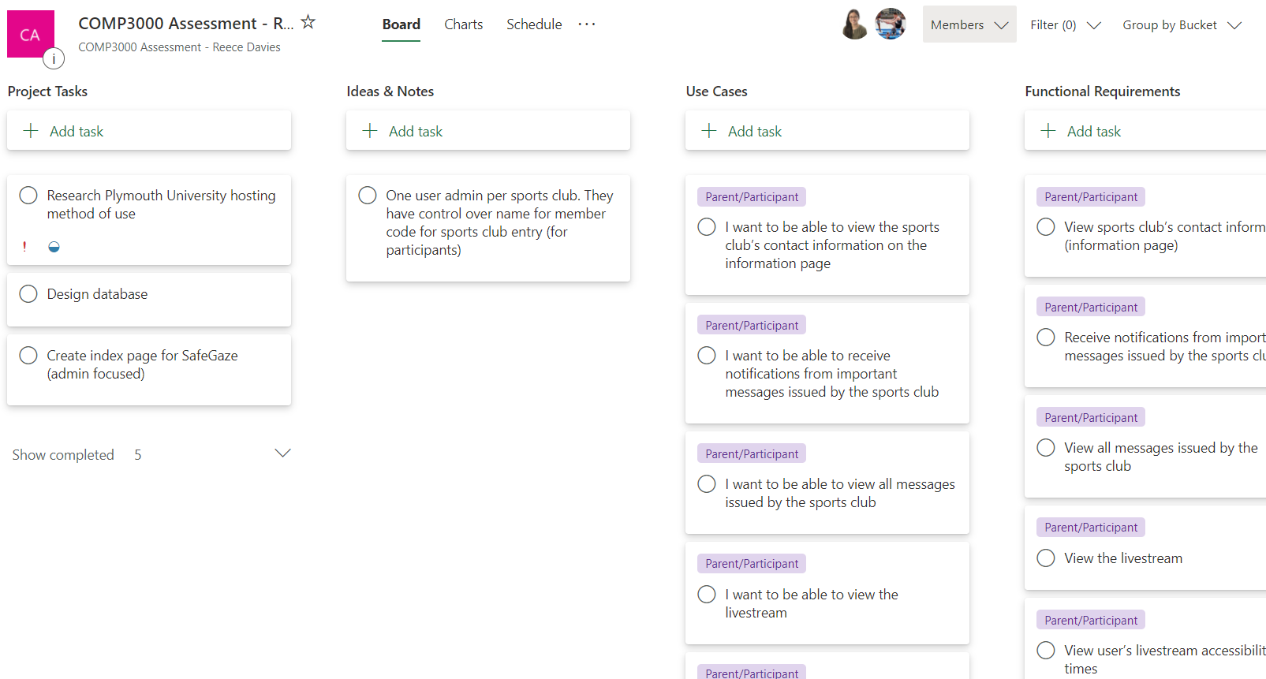

## Bi-weekly report #3 (Fri 13 Nov 2020)

The weekly report has recently change to Bi-Weekly reports. Within the previous two weeks I have designed the database as well as created the SQL code for creating the tables. To confirm that the database has been normalised properly, I have contacted my project supervisor for any changes that might be beneficial, or mandatory. Additionally, I have also added an SQL script that will add sample data to the database which will be used for testing on the prototype (dev system); this was achieved using the software PHPMyAdmin. Further planning has been done on the project backlog (Microsoft Planner) in which tasks have been allocated into separate sprints, therefore allowing me to track my progress for the entirety of the project. Lastly, the deliverable has been started; the directories have been configured in the correct manner and it currently contains the index page.

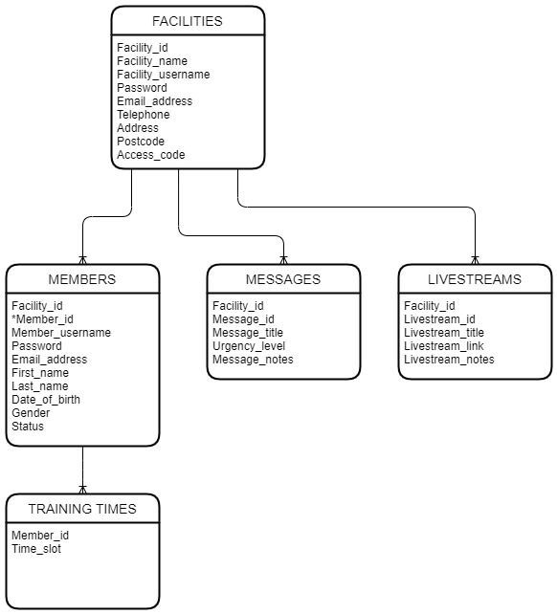

## Bi-weekly report #4 (Fri 27 Nov 2020)

Within the previous two weeks I started working on the deliverable where facilities are able to register a new account, as well as then being able to log in and out of their account. The PHP backend was also finetuned for security purposes. Subsequently, the numerous facility pages were set up and a dashboard UI design was created (using Bootstrap). This will be for listing members for the facility and therefore being able to manage them accordingly. Additionally, the navigation bar and dashboard UI were finetuned to be better suited for this specific website.

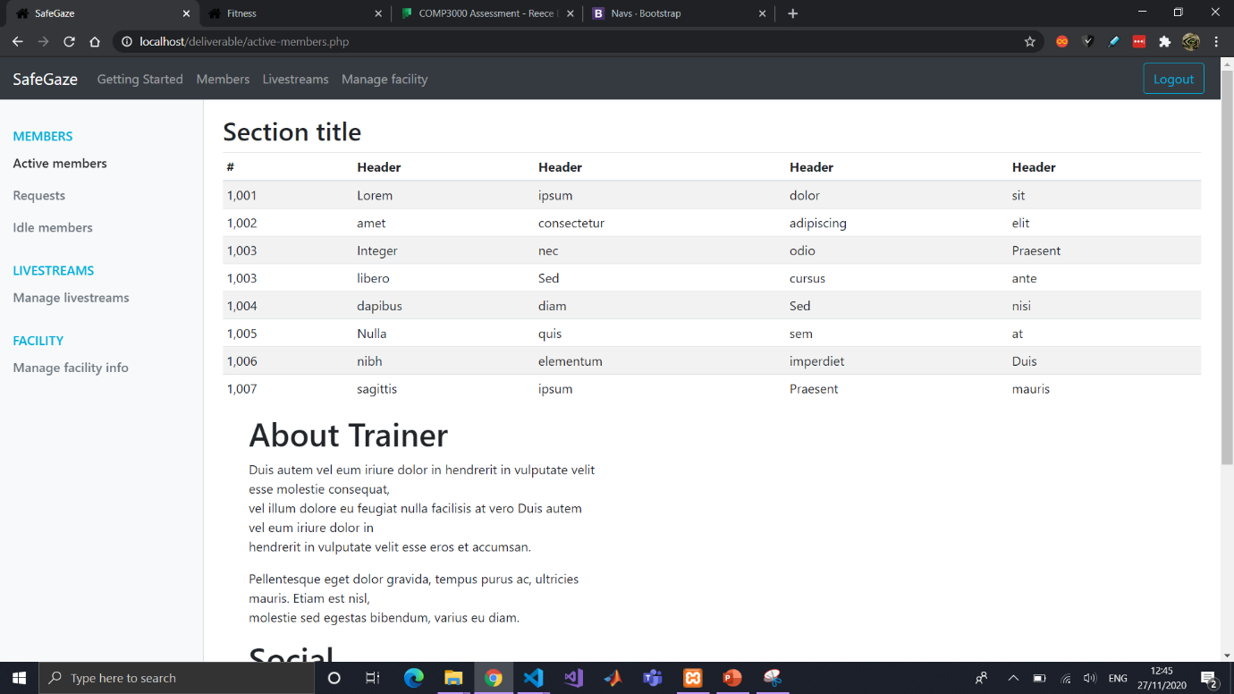

## Bi-weekly report #5 (Fri 11 Dec 2020)

Unfortunately, due to other university modules having deadlines within these two weeks, I have been unable to do much work on the Computing Project. However, I have organised the tasks in the project backlog into separate sprints for a more organised structure. This means I will understand which tasks I must allocate to myself first and thus the time management for this project will be more efficient.

## Bi-weekly report #6 (Fri 01 Jan 2021)

During the Christmas holiday, the focus was on allowing a Facility to manage its members. The different member pages (active, requests and idle) have been connected to the database and will link the different members according to their account status (accepted, pending, declined, and inactive). The active members page and idle members page have buttons that take the user to a new page which will be used to change the member’s status and access times. Furthermore, members are able to request for a new account, which is linked to the facility through the facility’s access code. They are then taken to a specific page which will decline the user access if they their status is anything other than “accepted”.

Furthermore, a “development process” document has been added which contains screenshots and notes of the deliverable. These notes and screenshots will primarily be used for the report in showing how the final deliverable has changed through time and what it had originally looked like.

## Bi-weekly report #7 (Fri 15 Jan 2021)

Started working on getting the livestream functionality working but having a lot of difficulty with it. Trying to connect IP camera to computer through RTSP. Works on VLC media player but can’t seem to connect it to embedded HTML code for the website (<https://videos.cctvcamerapros.com/i/ip-camera-streaming-website.html>) but might instead use a YouTube (or other streaming service) for the livestream functionality (<https://videos.cctvcamerapros.com/i/ip-camera-streaming-website.html>). Upon further research I found that I required additional hardware – a capture card. This would allow the DSLR camera to output live footage to the computer to be encoded for the stream, and thus I ordered one off amazon.co.uk. In the meantime I continued work on the ‘manage member’ page, specifically the training times and a few smaller things on different pages.

## Bi-weekly report #8 (Fri 29 Jan 2021)

Been very busy due to lockdown the 3rd. Adjusted the training_times table in DB to allow for check what training times the member has access to. Changed ERD and code in repository to reflect these changes. Created a user verification system that will check if status of the member and allow access if they have status “active” but not if they are anything otherwise (pending, inactive, declined). If they have not been accepted, they will be forced to the verification-page which displays their status (which will give an explanation to user – not yet implemented).

Facility can now manage a member’s training times by clicking the relevant checkboxes; DB row for the specific user is reset and updated with the new values selected.

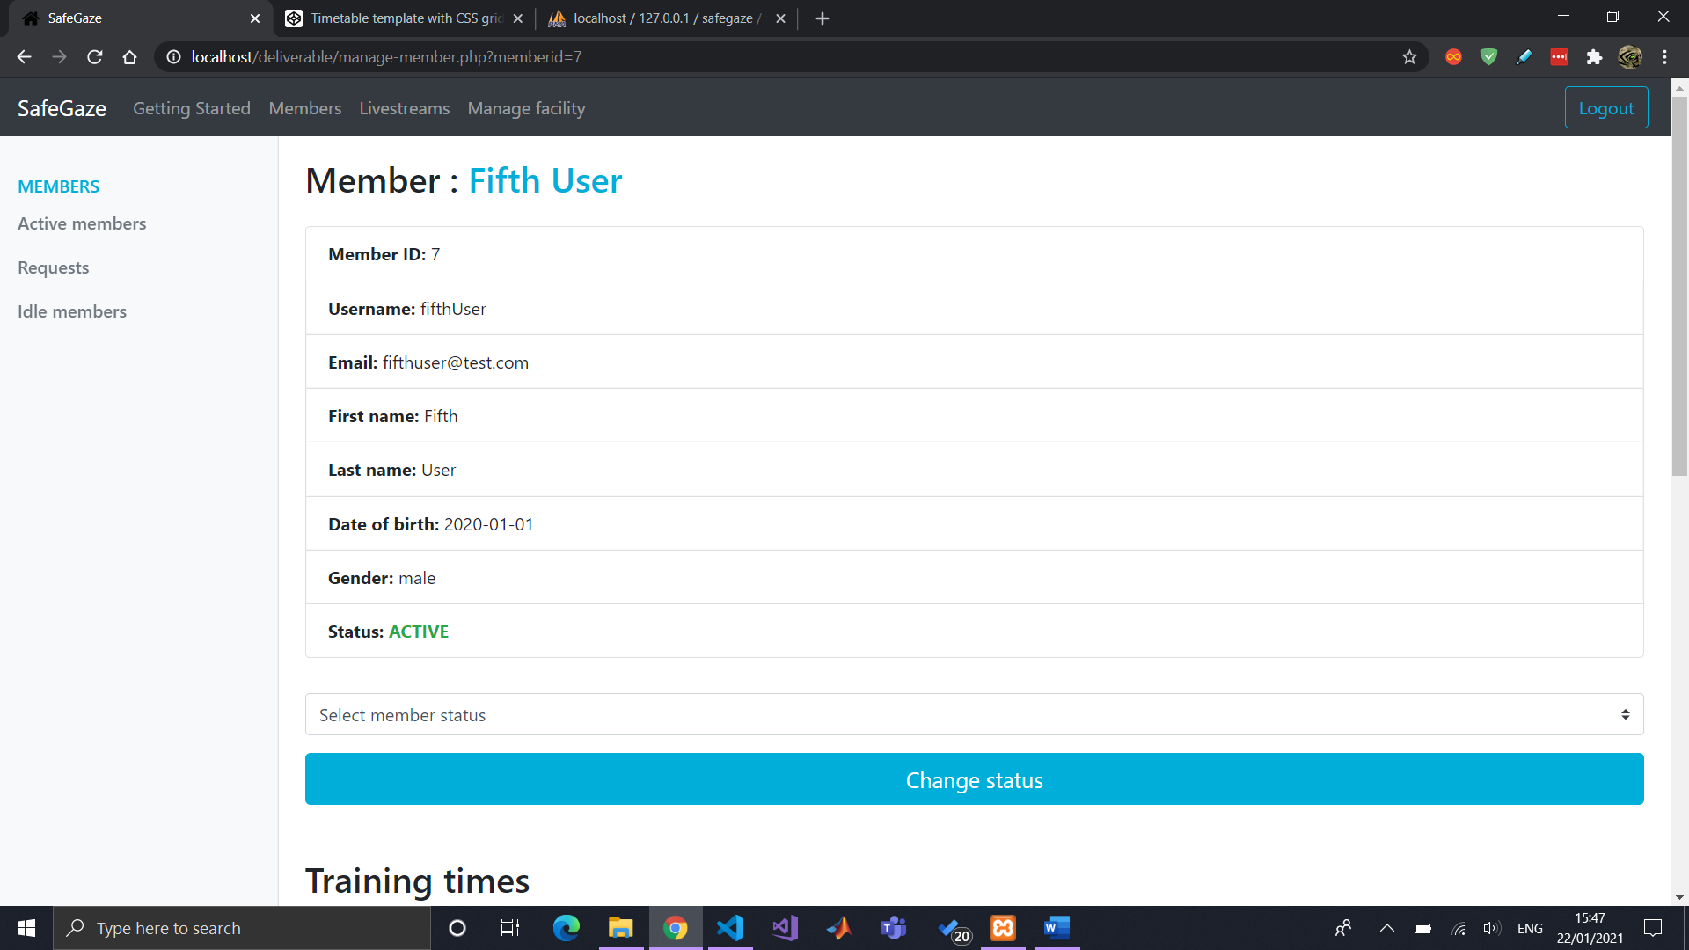

Updated manage-member page for listing the member’s training times in the form of a table. Refined the manage-member styling to exclude unnecessary content. Connected and started testing streaming the capture card to the laptop. Researched process for livestreaming using capture card. Requested streaming access from YouTube for testing (takes at least 24 hours for verification). In the meantime, created manage-livestreams page for facility.

Testing out livestreams. Complicated. Will be using YouTube as a proof of concept for the time being and then migrate to a secure private streaming service in the future (costs money). YouTube has security flaws with this type of security application and some tedious things (stated in important livestream notes document).

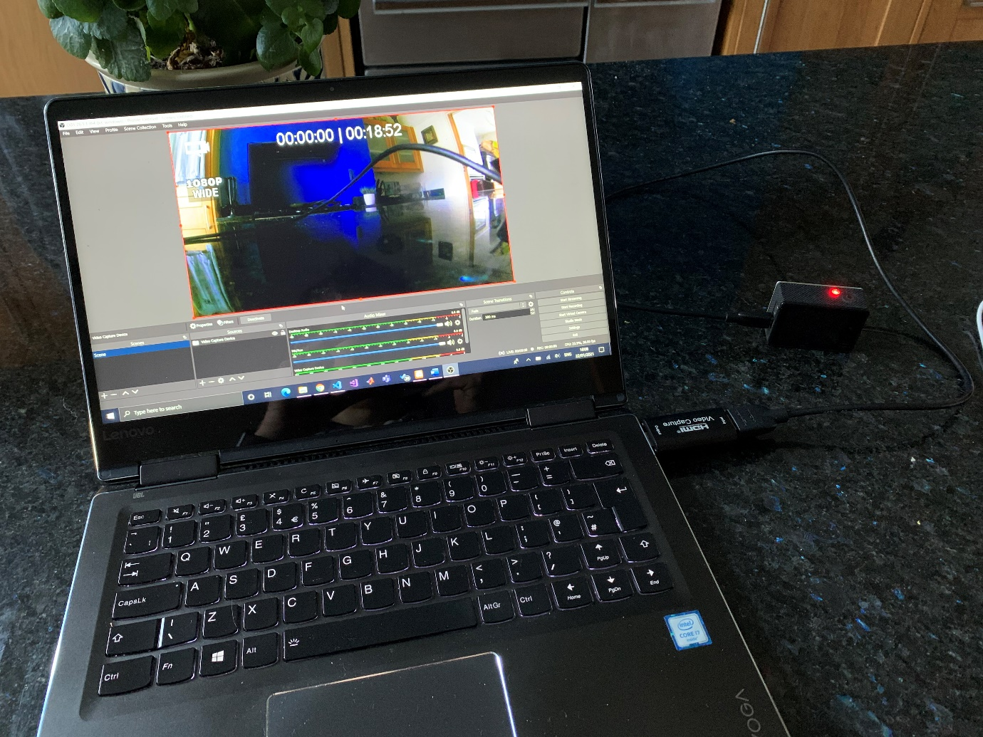

Working on assessing the member’s training times and giving restricted access. Started and finished backend script for posting livestream URL to database but need to decide if a facility will have one or numerous livestreams. Multiple livestreams decided.

Started listing all available livestreams facility offers along with their details. Next steps to finish styling livestreams list for facility (styling it as at the moment it does not look professional) and start listing livestreams for members.

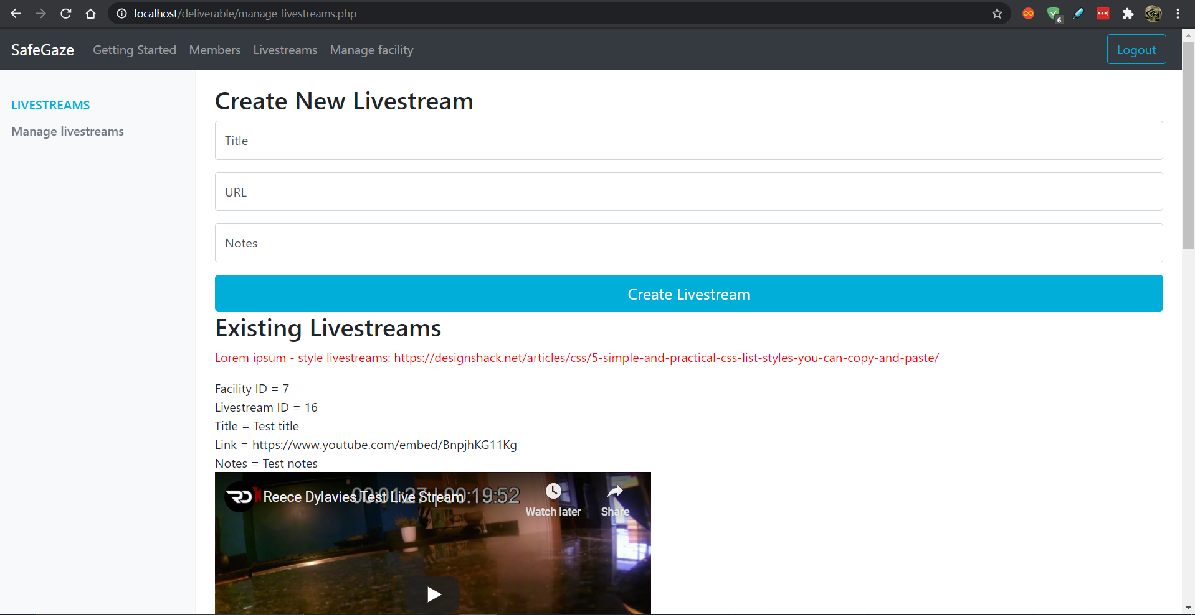

## Bi-weekly report #9 (Fri 12 Feb 2021)

Styled livestreams listview on facility’s manage-livestream page.

Allowed livestream to delete livestream.

Displayed list of member’s access times on their livestream page.

Styled verify-user page for members when their account is pending/inactive/declined.

Styled member’s livestream page with notification of access time + short message.

Connected DB livestreams to appear in member’s livestream page + styled them.

Created footer and styled it.

Facility can update their information (excluding some like email address and username).

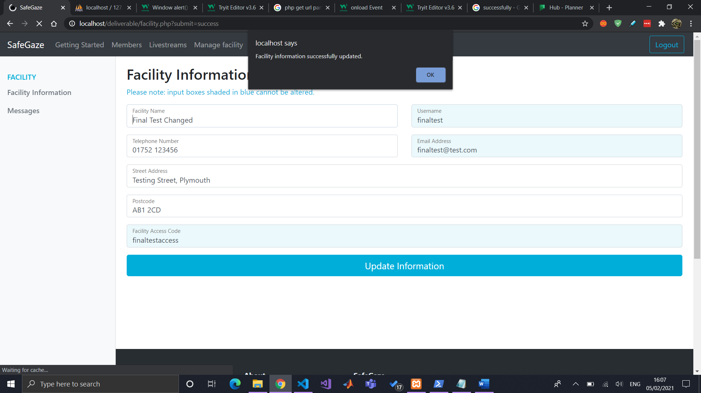

Members can now view their facility’s details.

Started page for facility to create and view all messages issued to members.

Then connected it to DB (with form) and improved styling.

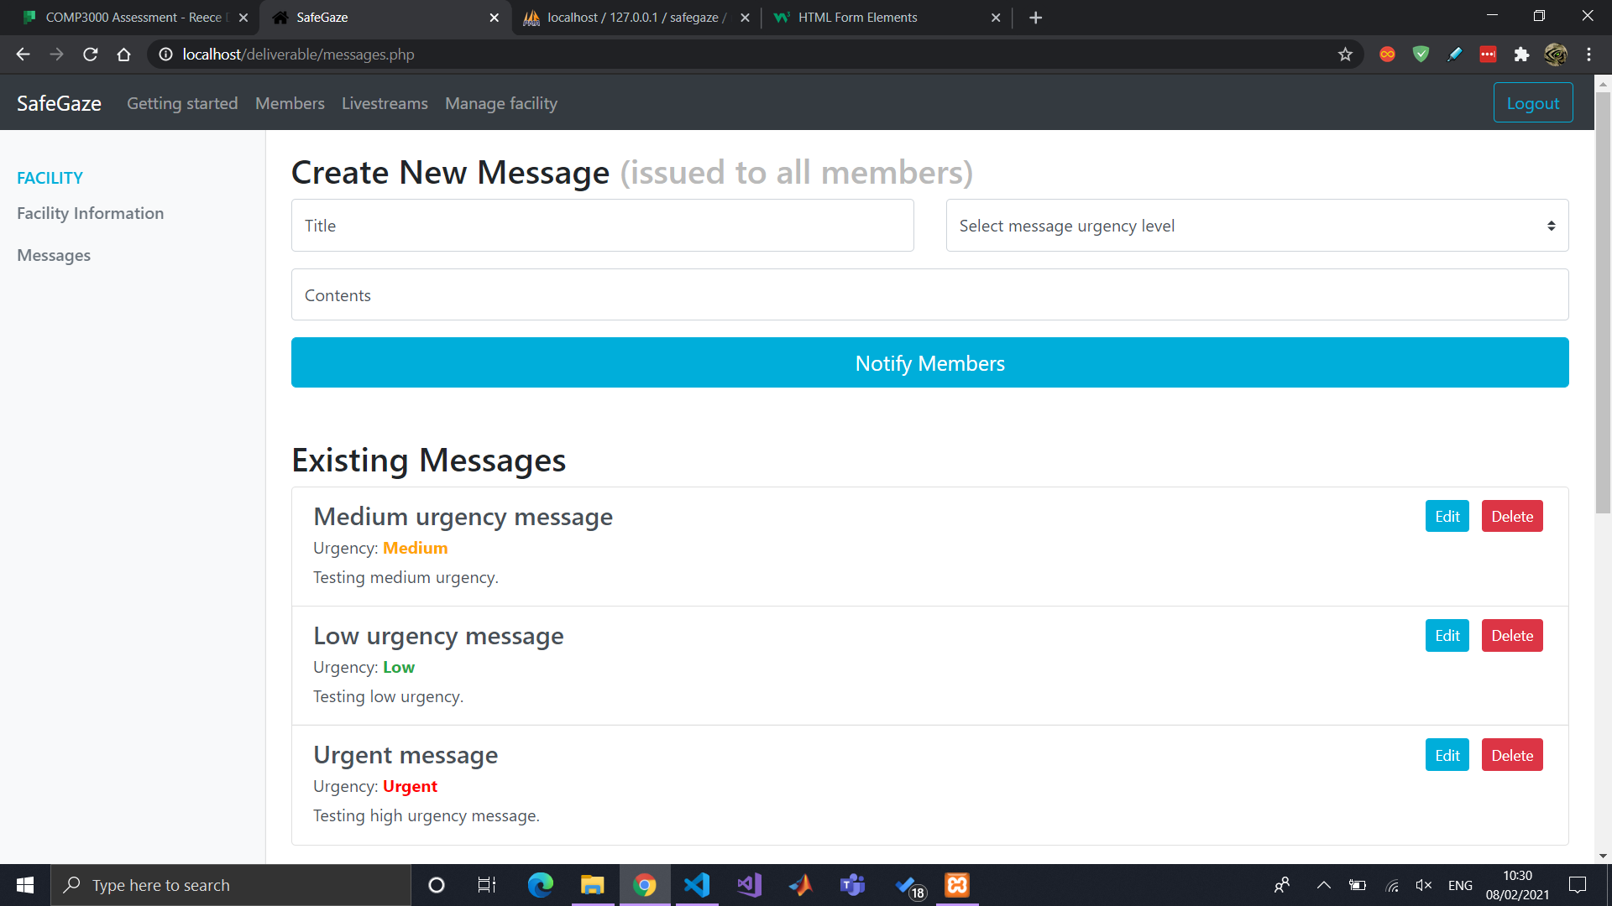

Styled facility and member login as well as navbar according to their colour scheme.

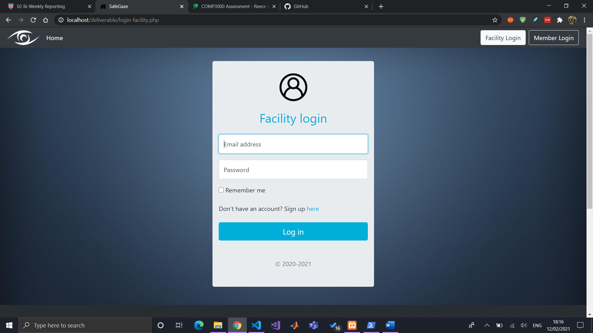

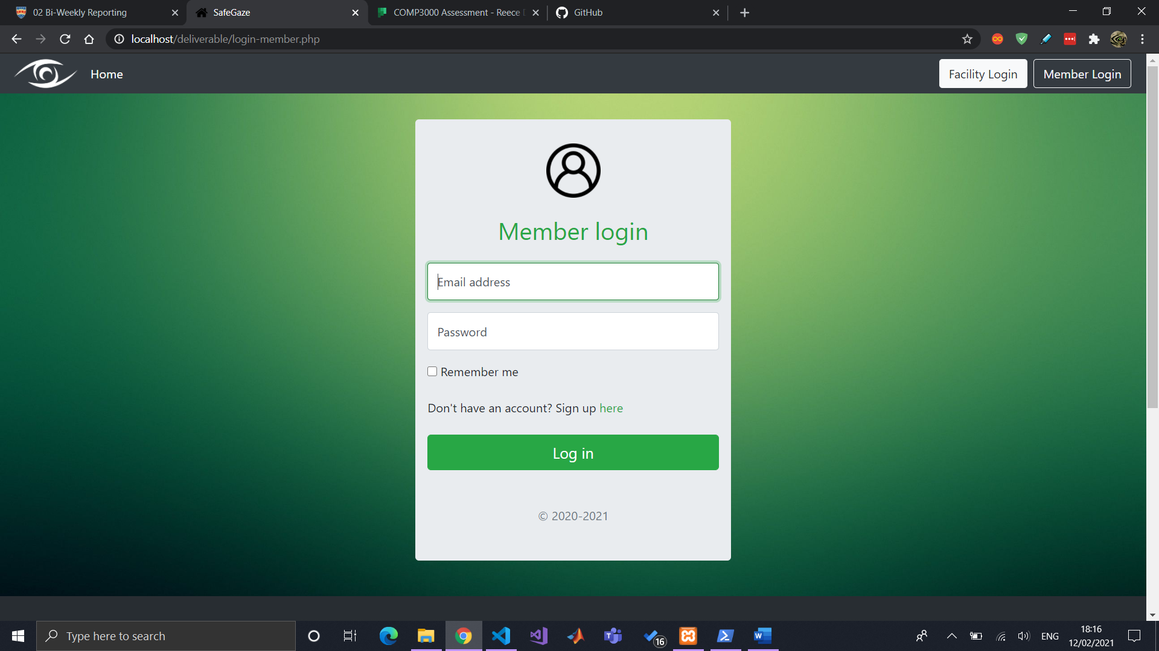

Created SafeGaze logo in Photoshop

Made small styling changes to website, including adding logo to navbar (with respected colour scheme) and footer.

Continued working on report.

## Bi-weekly report #10 (Fri 26 Feb 2021)

Styled the index page for better presentation.

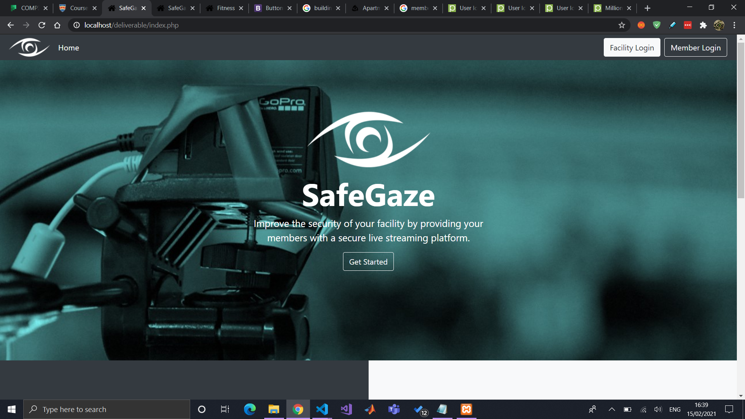

Started working on the “Getting started guide” document which will act as documentation for the facilities in the “getting-started” page.

Sent video demonstration to client (Exeter Trampoline Academy) for constructive feedback on potential improvements. Response has been received and it has been input into a word document called “ETA feedback.docx”.

Input content into “Getting started” page, for documentation, and also acting as script for showcase video demonstration.

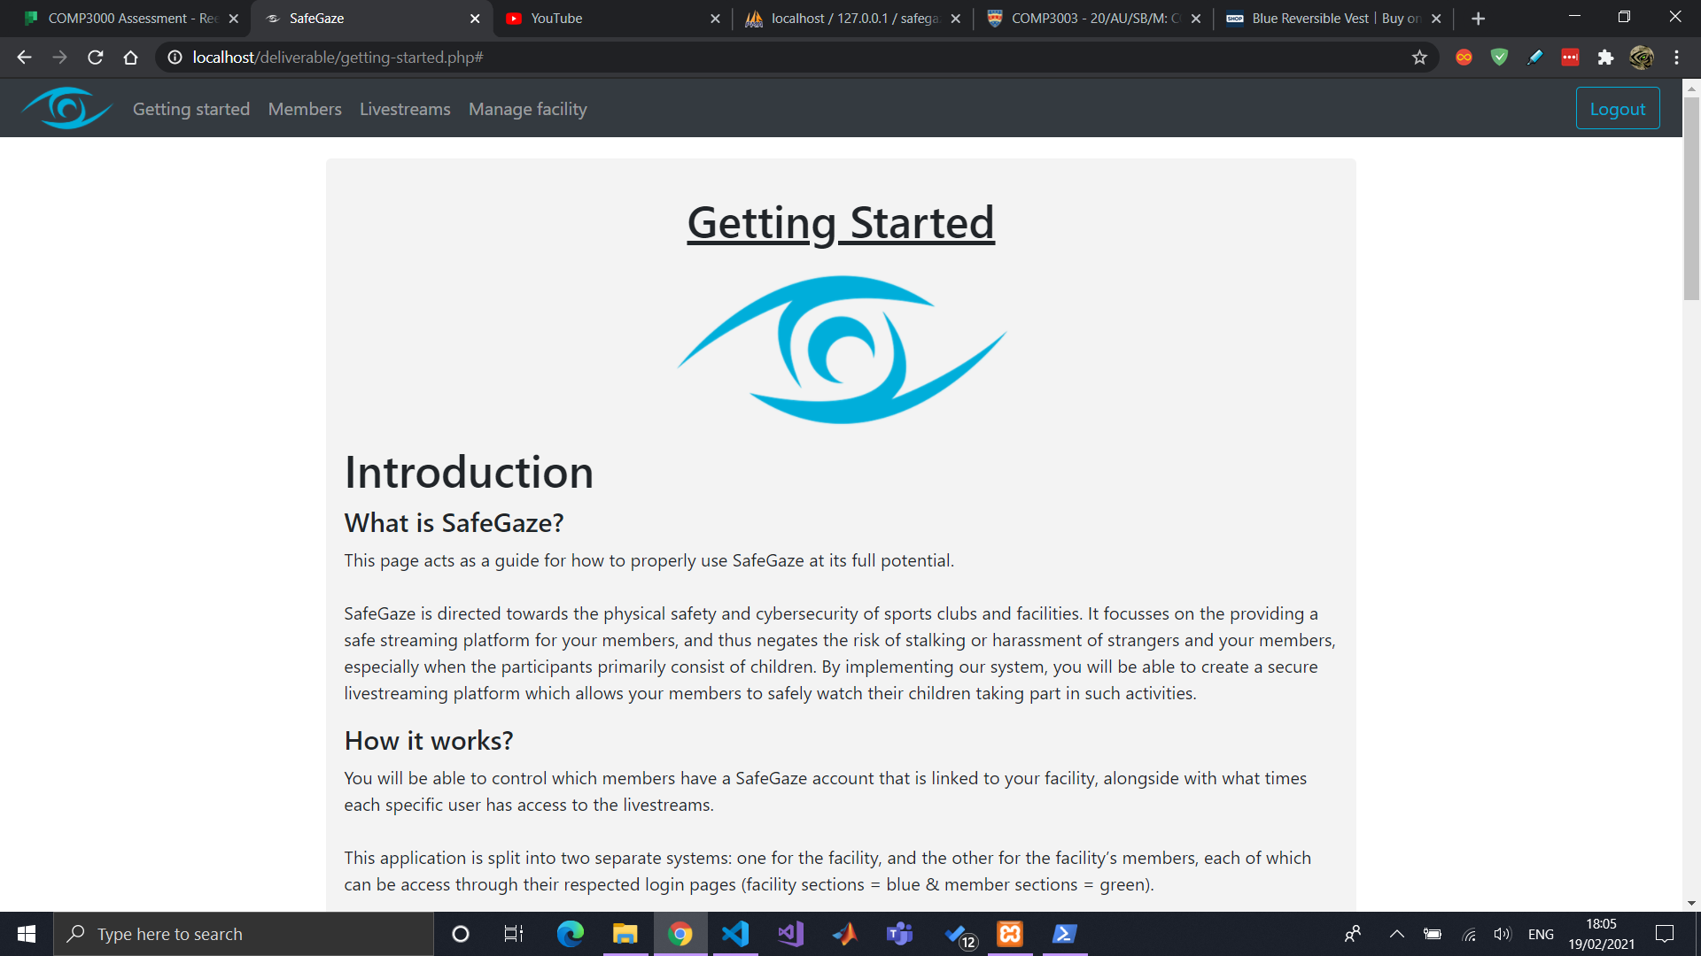

Took content from “Getting started” guide and transferred it into a script for showcase materials video demonstration.

Did a little more work on Report (introduction section – project aims & objectives).

Started and finished project poster for showcase materials. Was not able to access Photoshop, so it was created with the use of GIMP. Also recorded the audio for the video. Screen video capture will be recorded Monday 1st March.

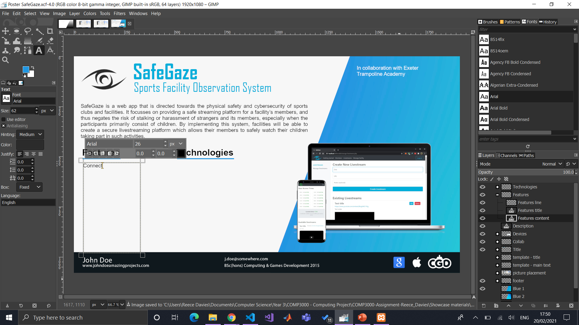

Facility can now edit a livestream’s details (all functionality of website is done – except notifications, which might instead be a future improvement to be stated in the report).

## Bi-weekly report #11 (Fri 12 Mar 2021)

Due to other module deadlines, I have not spent too much time working on it within the past week. Although, being very organised with SafeGaze’s project, I have finished and submitted the showcase materials. Alongside this, I have finished editing the video demonstration and uploaded it to YouTube.

## Bi-weekly report #12 (Fri 26 Mar 2021)

Been working on report. Finished introduction section and started project management section (the importance of project management + method of approach + explaining bi-weekly supervisor meetings and DLE blog reports).

## Bi-weekly report #13 (Fri 23 Apr 2021)

Report has made decent progress. Currently done just under 6,000 words and on the “Project Phases” section where I explain the development process of each sprint. Once that is done, the remaining sections are the end project report, post-mortem, which will include some things like client feedback, improvements, difficulties, etc.

On Wed 21st Apr 2021, I had a face to face sit-down meeting with Polly (ETA CEO) to see if we can get SafeGaze set up. To my surprise, there were a few issues that would prevent this from happening, with the primary reason being that the access times cannot be relative to a specific day of the week. This was a problem because some members at ETA train only on set days, therefore raising the ethical issue of SafeGaze members able to access the livestream at their given access time throughout the entirety of the week, when in fact it would be desirable for them to only access it on a Monday, as an example. I created a document of their feedback and general discussions of the meeting. Just to mention, she really liked the system.

Instead, due to her maternity leave which commences Saturday 24th Apr, I will be setting up SafeGaze for her account so she will be able to monitor the facility while away. This is will also allow for her to provide me with some more useful feedback on testing the somewhat ‘production’ version of the system.

## Bi-weekly report #14 (Fri 7 May 2021)

Report is nearly completed. Just writing the “end project report” and “project post-mortem”. Once that this done, it is just refining the figures, references, and appendix.